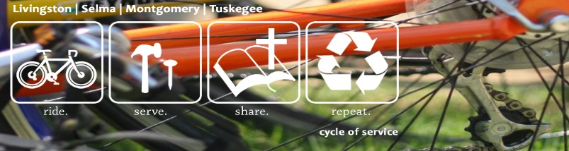
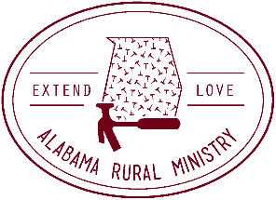

ARM CYCLE OF SERVICE SPONSORSHIP FORM
NEIGHBORHOOD RIDE/SPIN CLASS COMPETITION

I am participating with Alabama Rural Ministry (ARM) and Cycle of Service by logging in spin miles with my spin class at

____________________________ gym or riding around my neighborhood in conjunction with ARM's 300 mile ride April 21-23. We are "spinning" and cycling to raise awareness about poverty housing in Alabama and have a team goal to spin 300 miles. The funds I raise will be used to repair more homes and help with children’s ministry. My goal is to raise $___________ and a team goal of $25,000! Would you consider sponsoring me for my miles?

Name | Address | Phone | Email | Per Mile | Flat Rate | Paid Y/N

