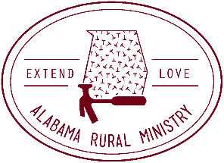
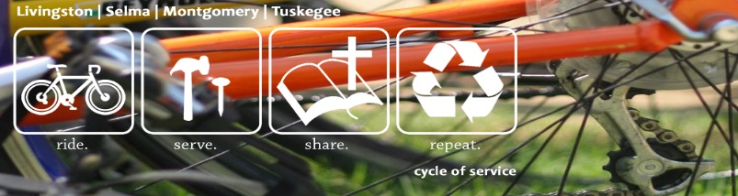

ARM CYCLE OF SERVICE SPONSORSHIP FORM

I am cycling across Alabama with Alabama Rural Ministry (ARM) and ARM Cycle of Service beginning April 21st and ending April 23rd My ride is to raise awareness about poverty housing in Alabama. The funds I raise through this trip will be used to repair more homes and help with children’s ministry. My goal is to raise $___________ and a team goal of $25,000! Would you consider sponsoring me?

Name | Address | Phone | Email | Per Mile | Flat Rate | Paid Y/N

