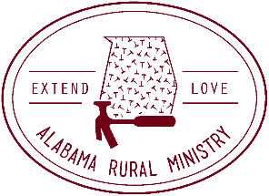
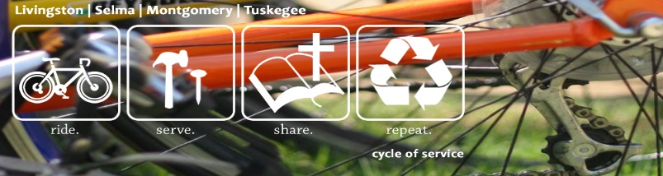

Alabama Rural Ministry
P.O. Box 2890
Auburn, AL. 36831
(334) 501-4276. www.arm-al.org

Dear Patron,

Alabama Rural Ministry (ARM) is sponsoring a bike ride across Alabama called Cycle of Service beginning April 21st in Livingston, AL, and ending April 23rd in Auburn. A few of us daring and brave individuals will be riding the entire distance, state to state approximately 300 miles. The purpose of the ride is to raise funds to help make homes warm, safe, and dry. ARM uses thousands of volunteers every year to help our elderly families, veterans, and others living on fixed incomes make critical repairs.

We will be riding 100 miles/day for three days. Our route will take us through Livingston, Cuba, Selma, Tuskegee, Phenix City, and Auburn. We are excited about all our ride will mean to our communities. Funds raised will help repair 40 more homes this year.

Our team has set a financial goal to raise $25,000 that will be used to repair homes in the Black Belt (a band of 13 counties stretching across our state). We hope that your business will consider being a sponsor of this ride. There are many ways a business can support us. Listed below are the tiers:

$1000 and above Cornerstone Sponsor | Name or logo on magnets for our travel trailer, team jersey and on everything below
$500 | Company logo on our t-shirt and web site
$250 | Company Name listed on our shirt and website.

If you would like to sponsor in one of the categories or in another way, please fill out the attached sheet and send back to us. For anything above the wall sponsorship, we must have these pledged by April 7th.

If you have any questions, please let us know.

Thanks so much,

Lisa Pierce Executive Director
Alabama Rural Ministry

Alabama Rural Ministry Corporate Sponsor Form:

Name of Business_________________________________________________________

Address____________________________________________ City_________________

State_____ Zip________________________ Phone_____________________________

Type of Sponsorship_______________________________________________________

Amount enclosed: $_______________________________________________________

Please include a copy of your logo or email us a PDF of JPEG file of your logo

Remit to P.O. Box 2890
Auburn, AL. 36831
cycle@arm-al.org
(334) 501-4276

