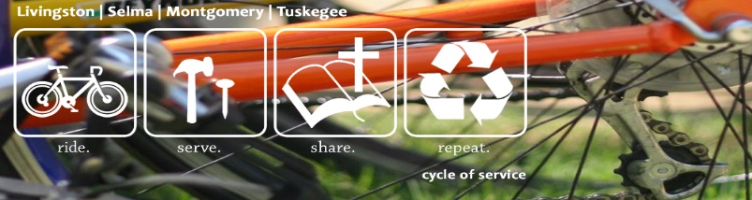
ARM CYCLE OF SERVICE
NEIGHBORHOOD RIDE/SPIN CLASS MILEAGE TRACKING SHEET

Date | Number of Miles | Total Number of Miles

