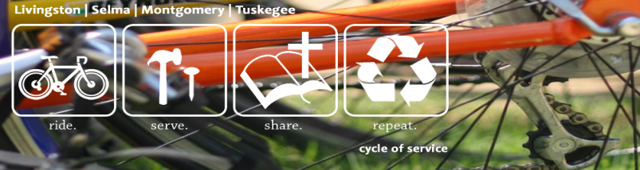

P.O. Box 2890
Auburn, AL. 36831

ARM Cycle of Service- Cycling With A Purpose….

[Personalize opening sentences]. I am cycling 245 miles across Alabama over three days. Pretty crazy, right? But did you know that in Alabama, there are hundreds of elderly women and men living in houses that are not warm, safe, or dry? And because they are on fixed incomes averaging $900 a month, making repairs is out of reach. Instead of a roof, there are pots and pans set out to catch water. Some homes have windows that are drafty and floors with holes. Living on fixed incomes makes simple repairs like fixing a toilet nearly impossible. I am riding because Alabama Rural Ministry (ARM) uses thousands of volunteers each year to help families receive vital repairs. They help make their homes warm, safe, and dry. My ride is going to help them raise the costs of materials like lumber, shingles, and dry wall for the groups.

I am inviting you to be a part of my plans for this Mayl! I have committed myself to making a difference. Through an event called Cycle of Service, I will ride 245 miles across the whole state of Alabama! It will support Alabama Rural Ministry (www.arm-al.org), a ministry in its 21st year of service that works to strengthen families and create sustainable homes by developing spiritual leaders deployed to transform communities!

From May 3-5, about 10-15 other riders and I will ride 245 miles going from Mississippi to the Chattahoochee River in Georgia. During the ride, we will be raising awareness about poverty housing. Our team goal is to raise $25,000 and my personal goal is to raise [your goal]. That is enough money to repair a small home for an elderly family on a fixed income.

Would you sponsor me for the 245 miles I will ride? As you are financially able, perhaps you can sponsor me at ten cents a mile, fifty cents, a dollar, or even more per mile. It would mean so much to me and these families. I invite you to see more about our trip on our website, www.cycleofservice.arm-al.org and to follow us on Cycle of Service's Facebook page during the ride. Thank you in advance for your prayers for the team this April and for your help in repairing a home in Alabama! We will stay in touch.

With sincere appreciation,
[your name]

Your Name

