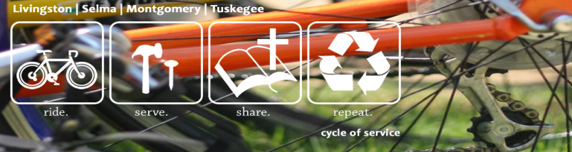

P.O. Box 2890
Auburn, AL. 36831

ARM Cycle of Service- Cycling With A Purpose….

Dear [Name], [Date]

[Personalize opening sentences]. I am cycling 245 miles! Pretty crazy, right? Why am I and others riding? So, we can help ARM repair homes for families on low incomes. Ms. Anderson is a single parent mom homeschooling her special needs son. Without a car, and critical repairs, she faces tough challenges. We are helping her make her home warm, safe, dry and beautiful! Your gift will help us help her-it is giving our ride purpose!

Living on fixed incomes makes simple repairs like fixing a toilet nearly impossible. I am cycling because Alabama Rural Ministry (ARM) uses thousands of volunteers each year to help families receive vital repairs. They help make their homes warm, safe, and dry. My ride is going to help them raise the costs of materials like lumber, shingles, and dry wall for the groups.

I am inviting you to be a part of my journey! I have committed myself to making a difference. Through an event called Cycle of Service, I will log 245 miles over the course of March 15-May 15th (insert spin bike, stationary bike, or riding in my neighborhood). It will support Alabama Rural Ministry (www.arm-al.org), a ministry in its 21st year of service that extends Christ’s love through home repair and children’s ministry.

I am cycling in conjunction with ARM’s ride across Alabama. From May 3-5, about 10-15 other riders are cycling 245 miles going from Mississippi to Georgia. We are all raising awareness about poverty housing. Our total team goal is to raise $25,000 and my personal goal is to raise [your goal]. That is enough money to repair a small home for an elderly family on a fixed income.

Would you sponsor me for the 245 miles I will ride? As you are financially able, perhaps you can sponsor me at ten cents a mile, fifty cents, a dollar, or even more per mile. It would mean so much to me and these families. I invite you to see more about our trip on our website, www.cycleofservice.arm-al.org and to follow us on Cycle of Service's Facebook page during the ride. Thank you in advance for your prayers for the team this April and for your help in repairing a home in Alabama! We will stay in touch.

With sincere appreciation,

Your Name

